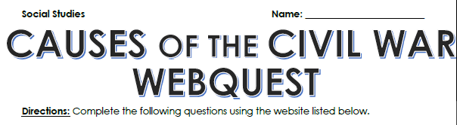
Follow link on shanleyhistory.weebly.com to complete questions
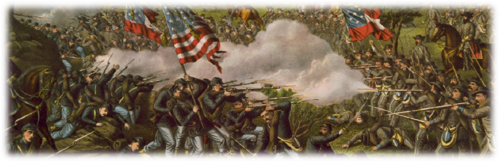
1. According to the website, what was the Civil War a culmination of?

2. Briefly explain the Missouri Compromise and how it led to the Civil War.

3. Who was Nat Turner?

4. Explain Nat Turner’s Rebellion.

5. How do you think Nat Turner’s Rebellion led to the Civil War?

6. What was the Wilmot Proviso? Explain.

7. What was the result of the Wilmot Proviso and how did it lead to the Civil War?

8. According to the website, what senators were involved in the creation of the Compromise of 1850?

9. Explain the Compromise of 1850.

10. How did the Compromise of 1850 lead to the Civil War?

11. Who wrote Uncle Tom’s Cabin?

12. What was Uncle Tom’s Cabin about?

13. How did Uncle Tom’s Cabin lead to the Civil War?

14. Explain the Kansas-Nebraska Act. What did it do?

15. When was the Kansas-Nebraska Act passed?

16. What was Bleeding Kansas? Explain.

17. Who was Dred Scott and what did he do?

18. What was the outcome of the Dred Scott Decision?

19. Who was John Brown?

20. Explain John Brown’s Raid.

21. What happened to John Brown?

22. When was Abraham Lincoln elected?

23. What party did Abraham Lincoln run as?

24. What occurred on April 12, 1861 at Fort Sumter?

25. What is the significance of the Battle of Fort Sumter?





